AD DL/SG group Manager – PowerShell script to align 'Owner' and 'ManagedBy' for a list of AD Security/Distribution Groups
This knowledge article provides step-by-step instructions and best practices for using a PowerShell script (have UI ) to update Active Directory Security Groups and Distribution Lists by aligning the “Owner” and “ManagedBy” attributes to a single designated user, and granting that user permission to update group membership.

Applicable To:
Service Desk
OSS

In This Article
- Introduction
- Prerequisites
- Steps & Powershell Script
- Verification, Outputs & Rollback

Content
Introduction
Use this procedure to standardize group ownership by setting each target group’s ManagedBy attribute to a single designated user and enabling the owner to update group membership. This tool reads a list of group email addresses, finds the corresponding AD groups, it can update ManagedBy and adds a permission entry (ACE) that grants the owner Write Property on the group’s member attribute. A result table is displayed and exported to CSV for audit.

Impact: Only management attributes and ACLs are changed. Group members, mail delivery, and other permissions remain unaffected.

Prerequisites
Please make sure following requirements are meet before running this shell in Windows 10/11:
- PowerShell version 7.x is installed on your system
- RSAT-AD-PowerShell feature installed
- You have an IT5 account (Not tested with PowerShell v6.x, not sure if this shell is compatible with v6.x
Initial Setup:
- Download the Shell on you PC local driver
- Open a PowerShell session with your IT5 account
- Run this shell use PowerShell version 7.x
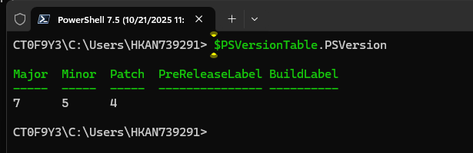
Steps & PowerShell Script
Add further instructions
Verification, Outputs & Rollback
Add further instructions

Escalation Process
<Assignment groups and escalation routes for unresolved tickets>

Related links
<Any related KBAs where appropriate>

Document Ownership
<IT Functional Team responsible>

